# Durable Furnitures

Noir

## French Country Sofa Table

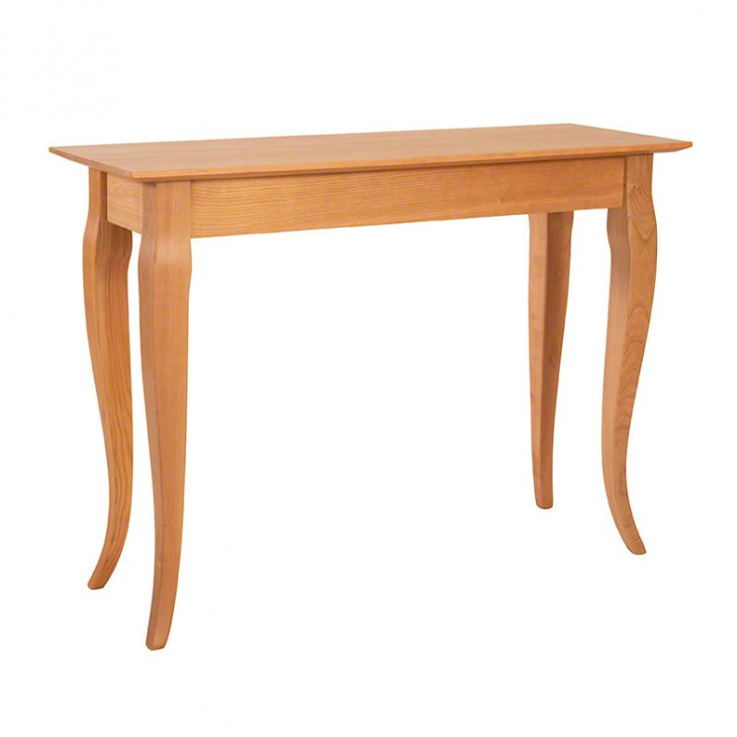

Our premium-quality, solid wood French Country Sofa Table is perfect for your home. You'll love the added luxury, style and convenience that comes with an extra space to place gloves or display photos, vases or artwork.